

**WINTER – SEMESTER**

**Course Code:** MCSE505P

**Course-Title:** – Computer Network Lab Component

**DIGITAL ASSIGNMENT – VI**

**(LAB) Slot-** L35+L36

**Faculty:** - SRIMATHI C (SCOPE) **Name:** Nidhi Singh

**Reg. No:** 22MAI0015

**DESIGN A WIRELESS NETWORK TOPOLOGY IN MININET**

**Installation**

* *git clone git://github.com/intrig-unicamp/mininet-wifi*

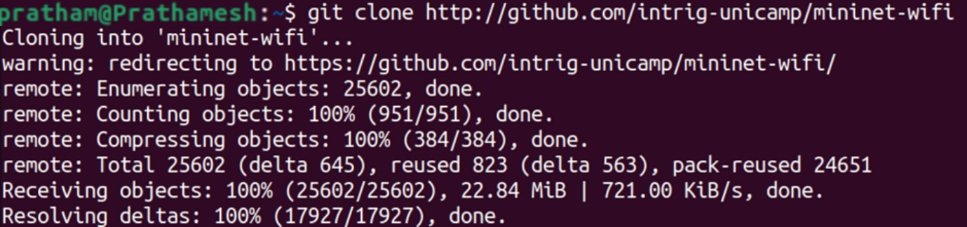

* *cd mininet-wifi*

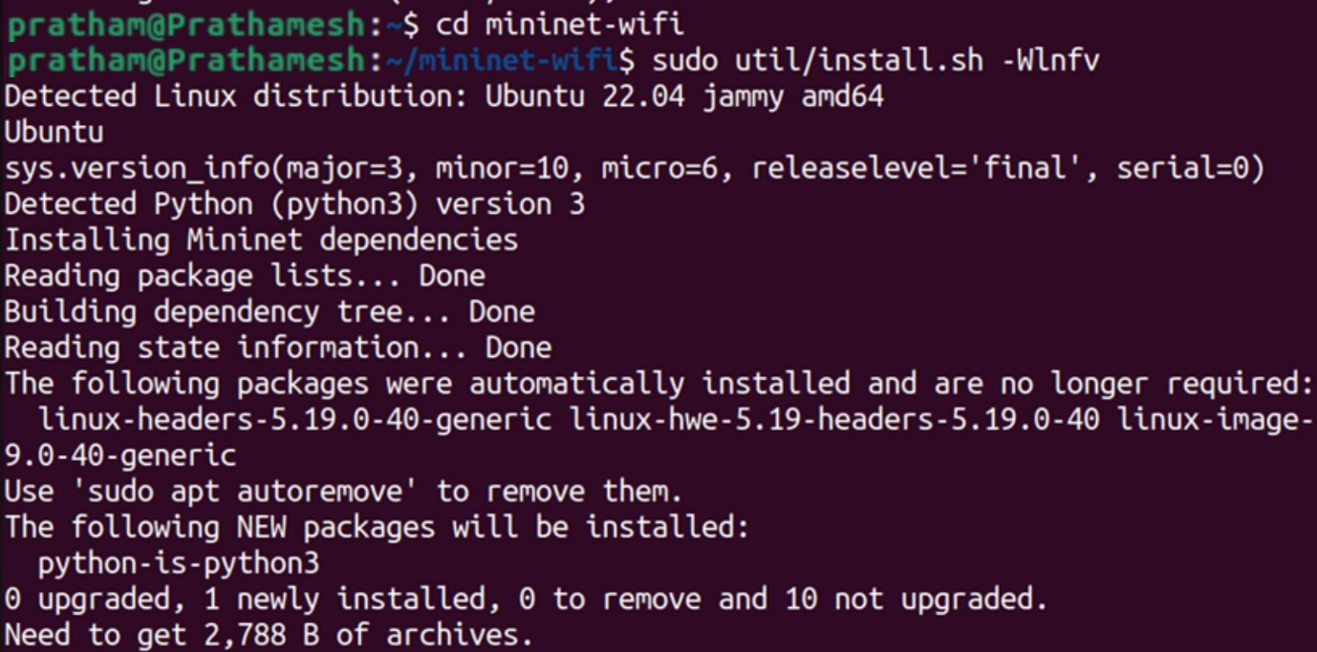

* *sudo mn –wifi*

***CREATING WIRELESS TOPOLOGIES***

* *sudo mn --wifi --topo single,3*

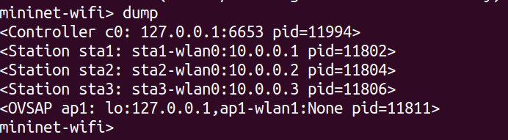

* *sudo mn --wifi --topo linear,4*

